9. BINARY SEARCH

**Aim**

To write a C program to search for an element in a sorted array using **Binary Search**.

**Algorithm**

1. Start.
2. Input array size n and sorted elements.
3. Input element to search (key).
4. Set low = 0, high = n - 1.
5. Repeat while low <= high:
   * Find mid = (low + high) / 2.
   * If arr[mid] == key → element found.
   * Else if key < arr[mid] → search left (high = mid - 1).
   * Else → search right (low = mid + 1).
6. If not found, print "Element not found".
7. Stop.

PROGRAM

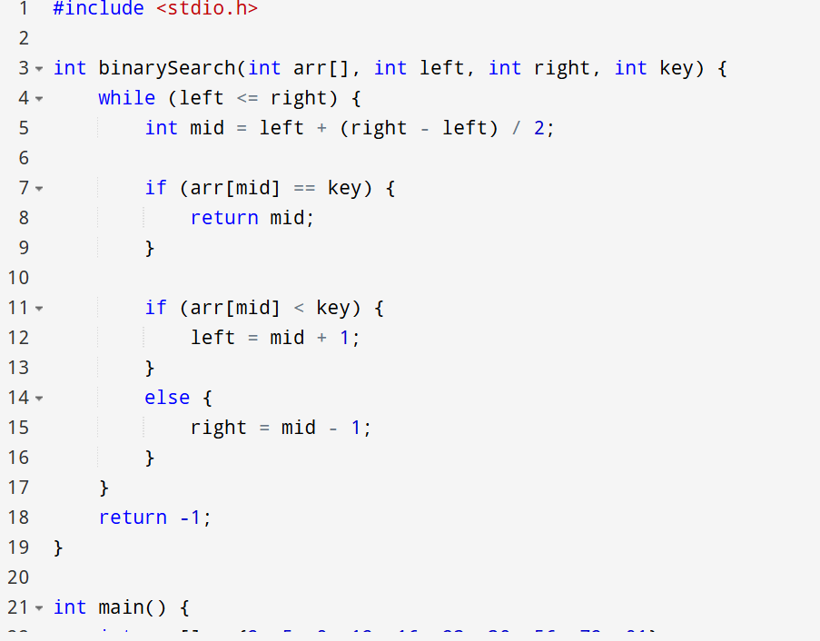

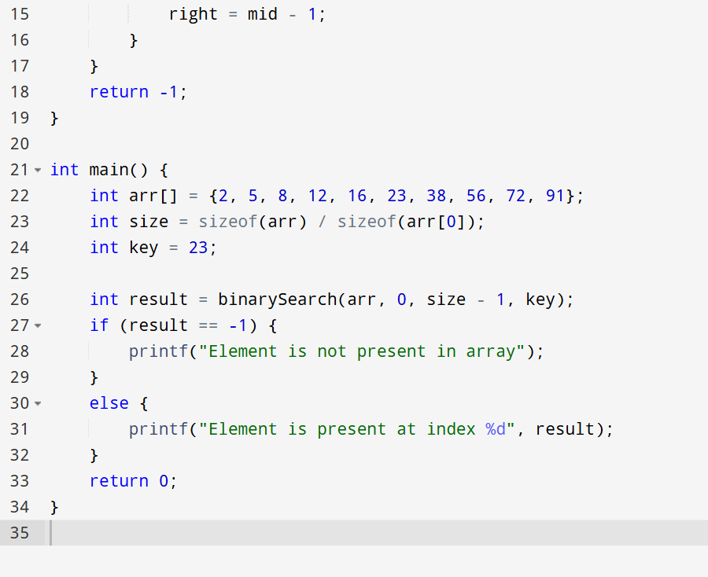

OUTPUT

